Lab 4: Bump Test Modeling

EEE4514

February 22, 2017

**Gabriel Stroe**

**Shawn Baumgartner**

# Filtering

## Overview

The purpose of this lab is to look create a first order system that matches the first order system that the servo motor produces. To do this we look and the output curve of the servo motor and used its data to create a matching transfer function.

## Theory and Methods

This is the basic first order transfer function that we used to replicate the servo motor is as follows: R(s) = K/(Ts+1) where K is the steady state value of our output over the steady state value of our input and T is our time at 63% of the steady state value subtracted by the time the function begins to rise. By looking at points from an output graph of our servo motor we can recreate this curve almost exactly.

## Results

As can be seen in the graph bellow our created curve matches the curve produce by the servo motor so closely it can barely be distinguished. (Servo is in yellow, Our function is in pink)

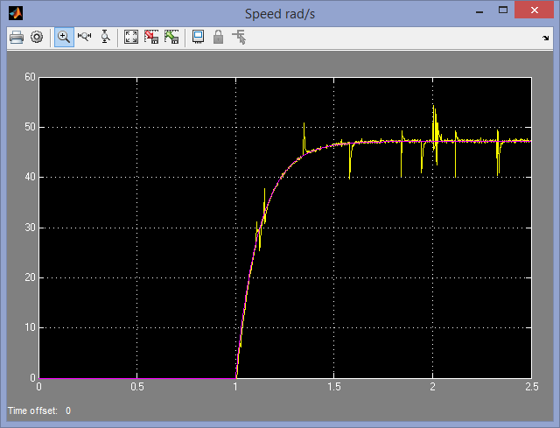

To do this we measured the steady state value which we found to be about 47.2. Then we calculated that 63% of that is 29.76 which corresponds to 1.124 seconds. Subtract our starting rise time of 1 second and we got 0.124 seconds for our value of T. Then knowing our step input was a steady state value of 2 we can take 47.2/2 and get 23.6 for our value of K. Thus our final transfer function is R(s) = 23.6/(0.124s+1).

## Questions

1. Yes, our model fit the servo motor exactly, which would indicate that our values for K and T were correct.

## Conclusions

From this lab we have learned that we can use the results of any specific system (the servo motor for this instance) and derive transfer functions in how that system works. In addition, it shows how we can use computer simulations to model exactly how any system would act. This understanding seems to be critical to the basis of controls engineering.